CS16.2.7 New Server Instance Installation Guide

*Version 1*.0  
22 March 2019

|  |  |  |  |
| --- | --- | --- | --- |
| **Version History:** | | | |
| **No.** | Date | **Issued by:** | **Comments:** |
| 1.0 | 22/03/19 | Sanugula Kamalakar |  |
| 2.0 |  |  |  |
|  |  |  |  |

|  |  |  |  |
| --- | --- | --- | --- |
| **Prior Approvals:** | | | |
| **Role/Approving Party** | **Name** | **Date** | **Signature** |
| Project Manager | BOLLINGH Mark |  |  |
|  | HORKAY László |  |  |

**Table of contents**

1. Executive Summary 4

2. Technical summary 4

3. Pre-requisits 4

4. CS 10.5 Sp1 Component Installations. 4

4.1. Oracle 12c Client Installation 4

4.2. IIS 8.5 Installation 8

4.3. Java Installation 11

4.4. Tomcat Installation 12

5. CS 10.5 sp1 Installation 16

5.1. CS 10.5 Installation 16

5.2. CS 10.5 Configuration with IIS 21

5.3. Install Optional Module 29

5.4. HotFixes and Latest Patches 29

5.5. Align the opentext.ini to EIB standard 29

6. VM Ethernet Configuration. 29

6.1. Disable Recv Segment Coalescing (IPv4) 29

7. Apache 2.4.x Installation 35

8. NSSM - the Non-Sucking Service Manager Installation. 37

9. Content Server Agent Set up with NSSM 37

# Executive Summary

This document is to provide any OpenText administrator understand the OpenText Content Server(16.2.7) installation & configuration has been executed.

# Technical summary

|  |  |
| --- | --- |
| **CS 10 Component** | **Version** |
| Windows | Windows 2016 Server R2 |
| Oracle Client | Oracle Database Server 12 - 64 bits |
| Oracle Client | 12c –12.1.0.2.01,6( Can be updated while installation ) |
| IIS | 8.58( Can be updated while installation ) |
| Java | jdk-8u92-windows-x64 ( Can be updated while installation ) |
| Tomcat | 8.0.33 ( Can be updated while installation ) |
| Content Server | 16.2.7 (2018-12) |

# Pre-requisites

N/A

# CS16.2.7 Component Installations.

## Oracle 12c Client Installation

* Create the following folder structure

“D:\apps\oracle\”

* Copy the oracle client installer from the source location

**To be confirmed the Location**

To the newly created structure: “D:\apps\oracle”

* Run the oracle client installer and insure that the application is installing on “D:\apps\oracle”

|  |  |  |
| --- | --- | --- |
| **Environment** | **Value** | **Description** |
| ORACLE_HOME | D:\apps\oracle\product\12.1.0\client | Oracle client 12c home |
| ORACLE Base | D:\apps\oracle\ | Oracle client 12c home |
| Software location | D:\apps\oracle\product\12.1.0\client | Oracle client 12c home |

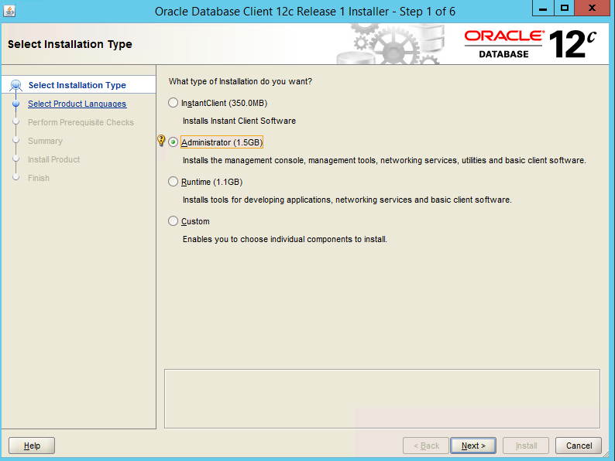

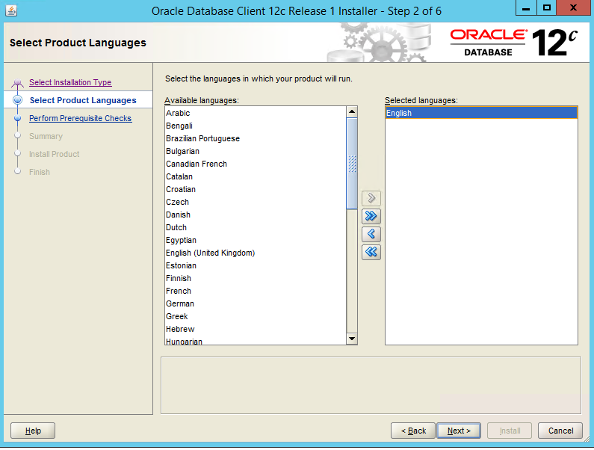

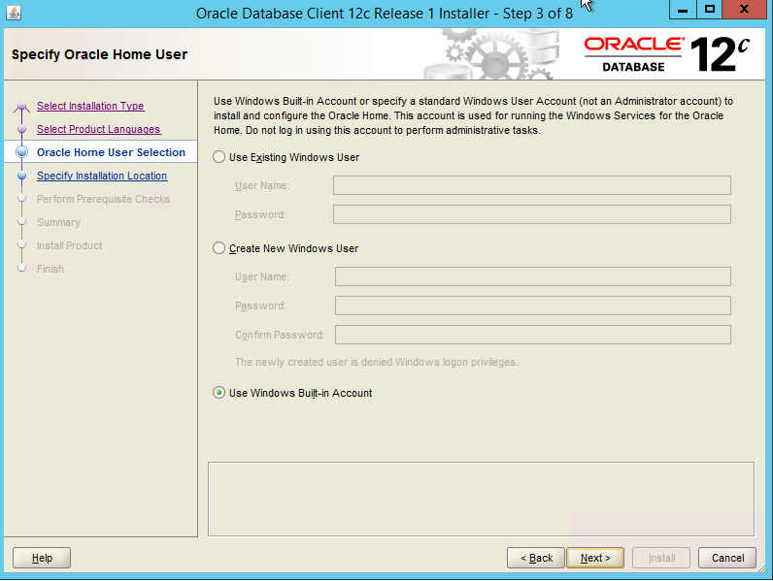  
  
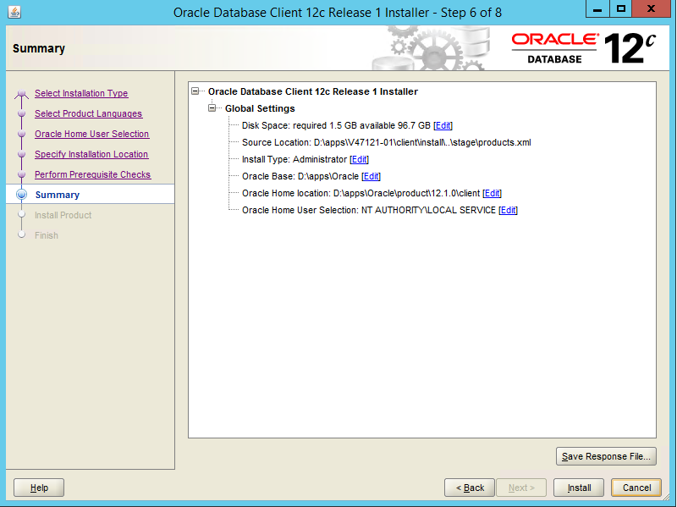

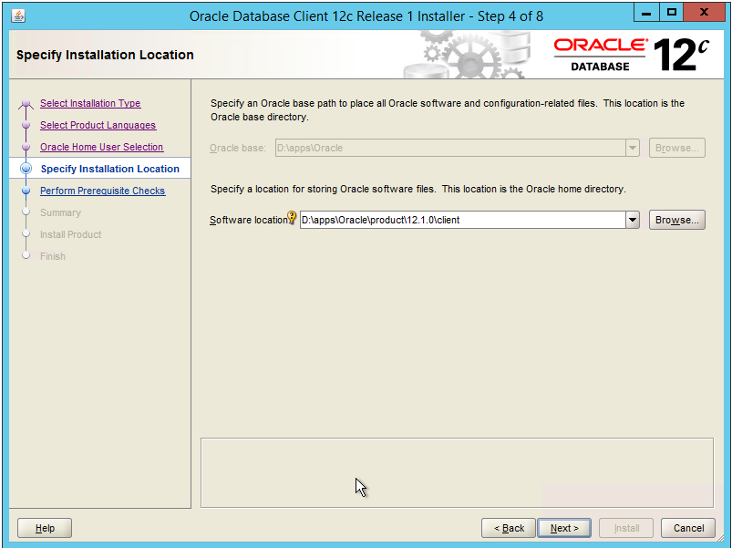

* Set up the oracle environment variable as below ORA_HOME=”D:\apps\Oracle\product\12.1.0\client”

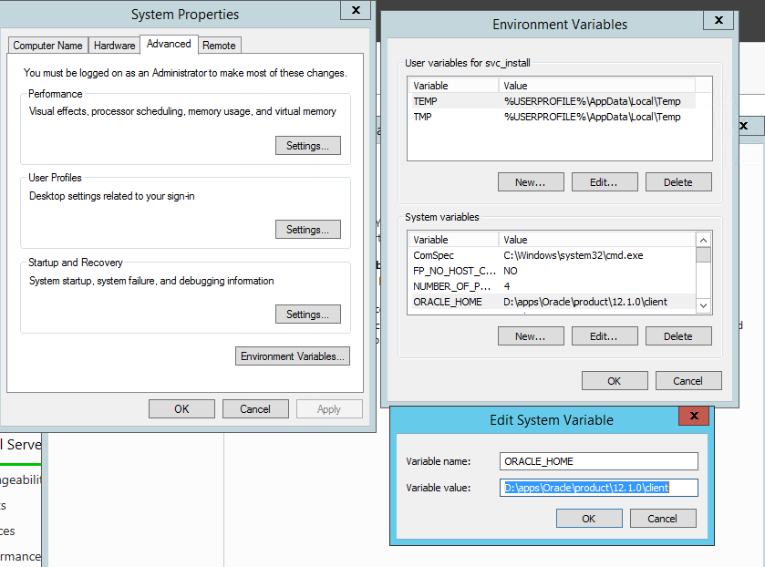

* Access the registry “HKEY_LOCAL_MACHINE\SOFTWARE\ORACLE\KEY_OraClient12Home1” and set up the oracle client NLS parameter as below:

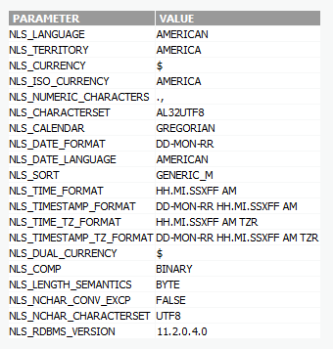

* Add the designated TNS port (see ORA_ADMIN\tnsname.ora) to the OTCS_Inbound and OTCS_Outbound firewall rules

## IIS 8.5 Installation

* Raise a CR with the Wintel team to install the IIS with .net 3.5 and 4.5
* DISM /Online /Enable-Feature /FeatureName:NetFx3 /All /LimitAccess /Source:\\beilux.eib.org\dsl\Windows Client Server Management\Servers\OS\W2K12-R2-Dct&Std-X64\W2K12R2\sources\sxs
* Configure IIS to Opentext Standard using the document “Case Study - Deploying Content Server 10.5 on Windows 2012 and SQL Server 2012.pdf” page 9 (Setup IIS 8.xx)

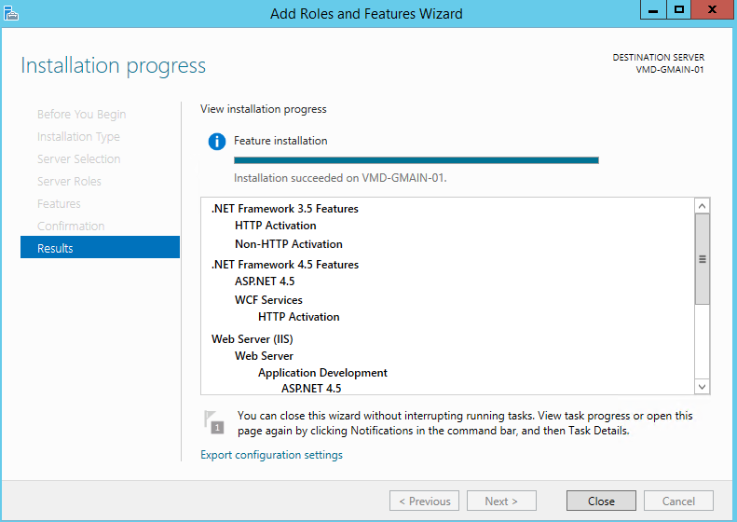

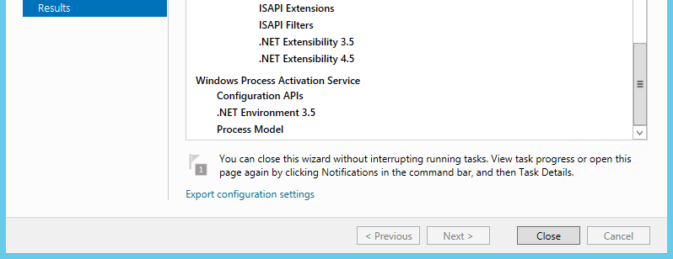

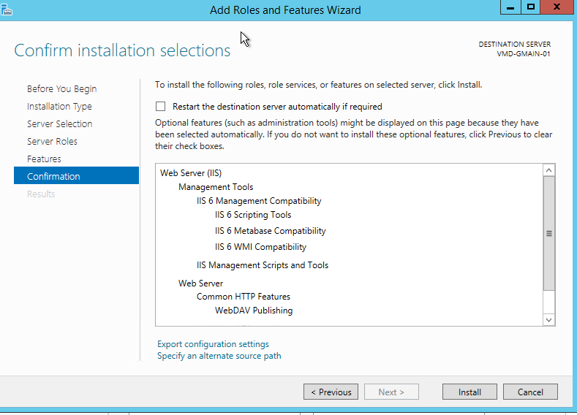

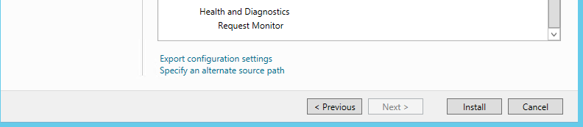

* Set the IIS logs to be located below

D:\apps\IIS\data

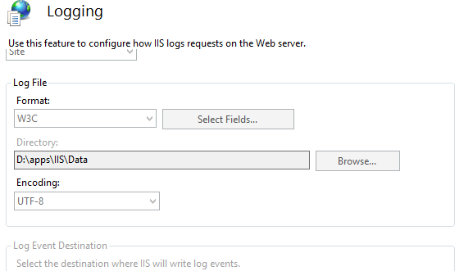

* Add the port 80 to the OTCS_Inbound and OTCS_Outbound firewall rules

## Java Installation

* Create the following folder structure

D:\apps\Java\8u92

* Copy the java installer from the source location

Path need to be confirmed

To the newly created structure: “D:\apps\Java\8u92”

* Run the java installer and insure that the application is installing on “D:\apps\Java\8u92”

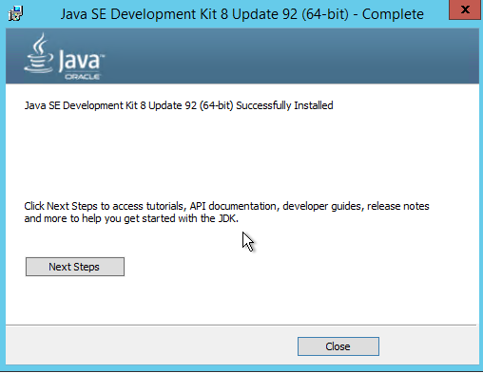

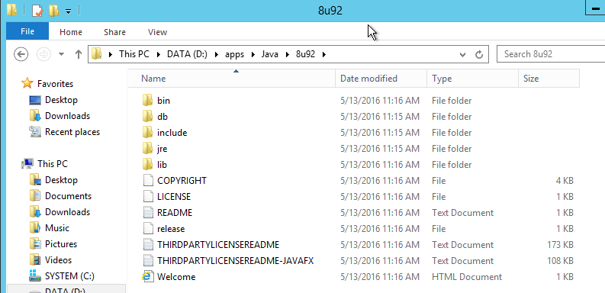

## Tomcat Installation

* Create the following folder structure

D:\apps\Tomcat\

* Copy the Apache tomcat installer “apache-tomcat-8.0.33.exe” from the source location

\\vmp-fs-09.beilux.eib.org\v_disk_01$\programs\EA_admin\OpenText\Admin\Upgrade\Software\Apache

To the newly created structure: D:\apps\Tomcat\

* Run the installer, insure that the applications is install in “D:\apps\Tomcat\”

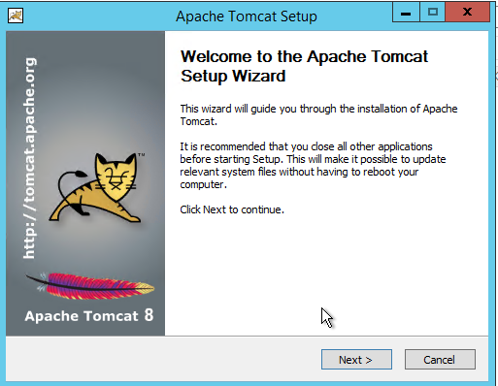

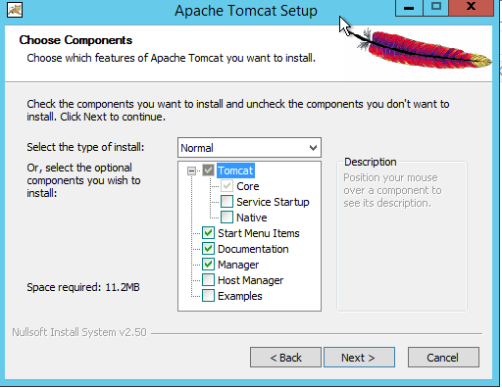

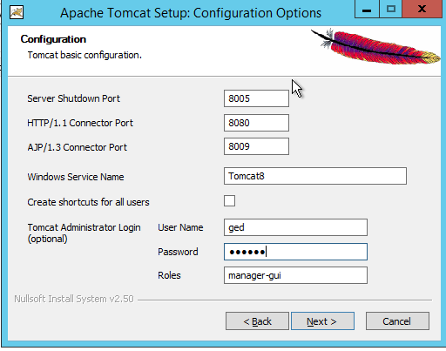

Set tomcat admin user to “ged”, password “ged105” and role “manager-gui”

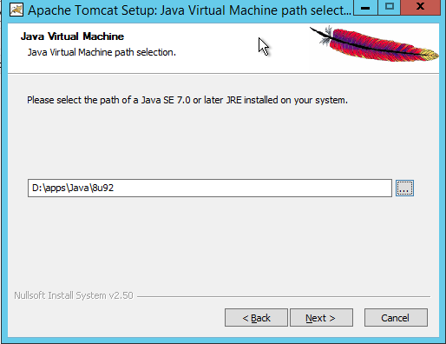

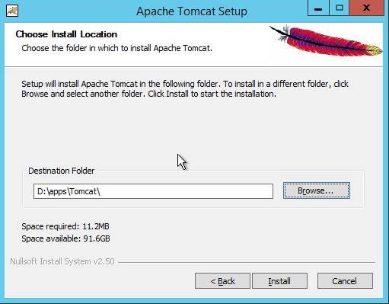

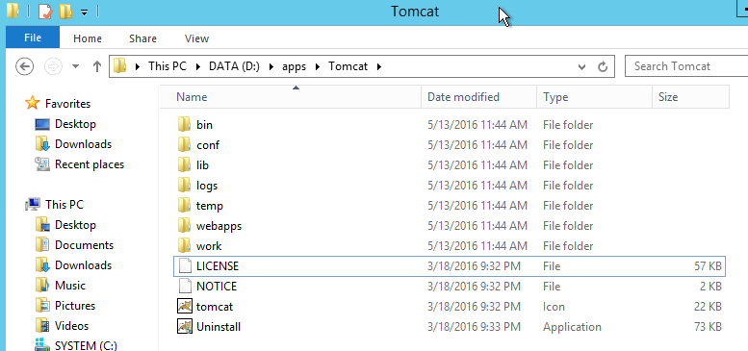

* Add the port 8080 to the CWS Inbound and CWS Outbound firewall rules

# CS 16.2.7 Installation

## CS 16.2.7 Installation

* Insure the followings:

-Tomcat service is down

-Oracle client is installed and configure.

* Create the following folder structure

D:\apps\OTCS

* Copy the CS installer “16.2.7_cs64_win.exe” from the source location

Path need to be confirmed

To the newly created structure: D:\apps\OTCS

* Run the installer, insure that the applications is installed in “D:\apps\OTCS\”

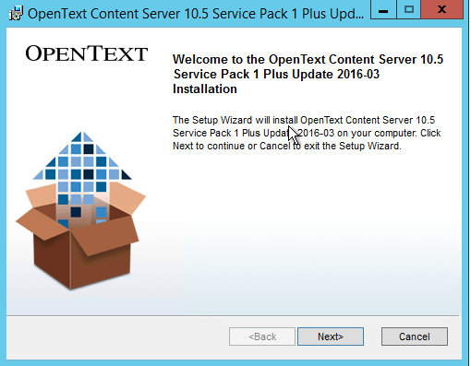

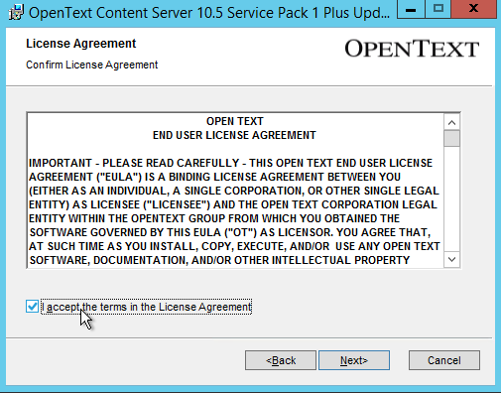

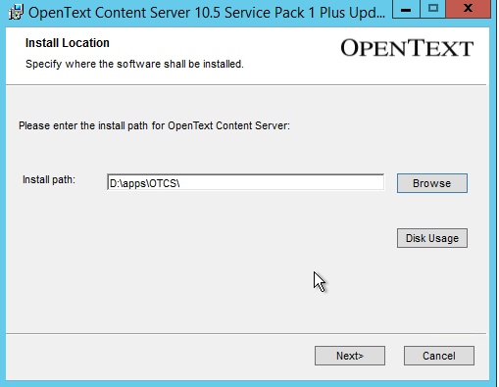

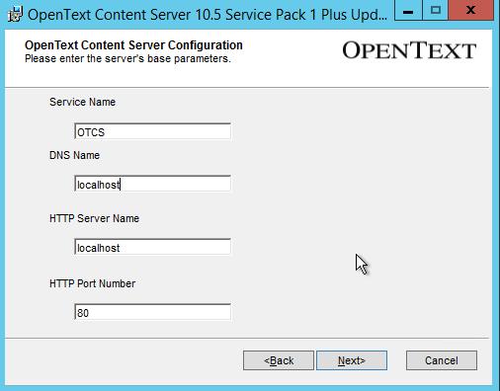

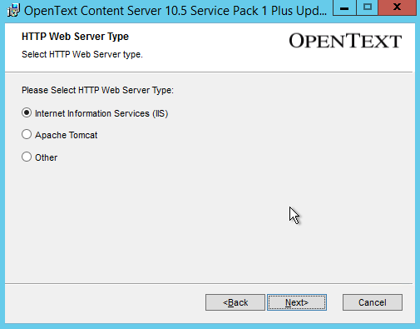

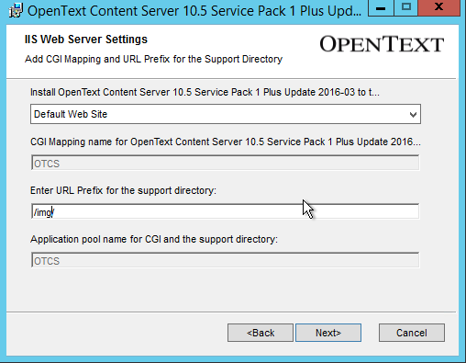

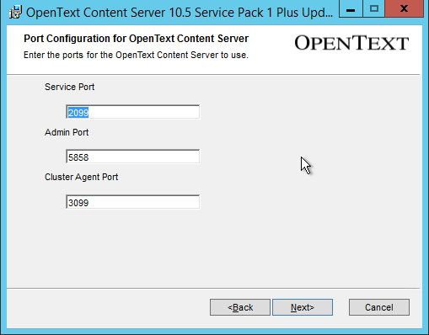

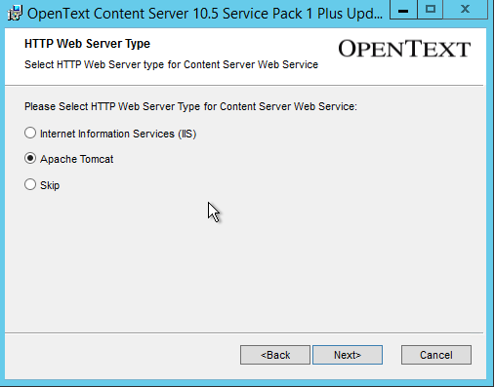

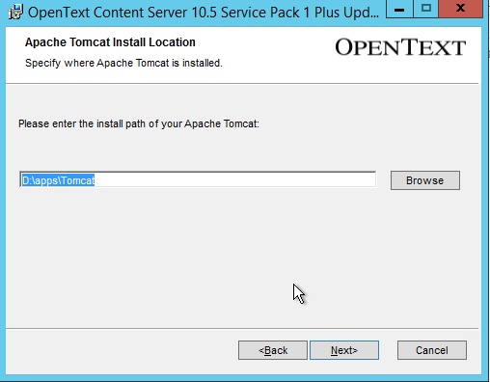

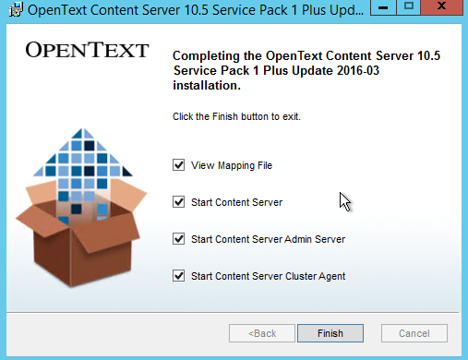

## CS 16.2.7 Configuration with IIS

* Configure the OpenText virtual directories in IIS 8 for OTCS 16.2.7 using the document “Case Study - Deploying Content Server 16.2.7 on Windows 2012 and SQL Server 2012.pdf” page 31 ( Phase Three: Configure IIS 8.xx)
* Configure Content Server to EIB Standard

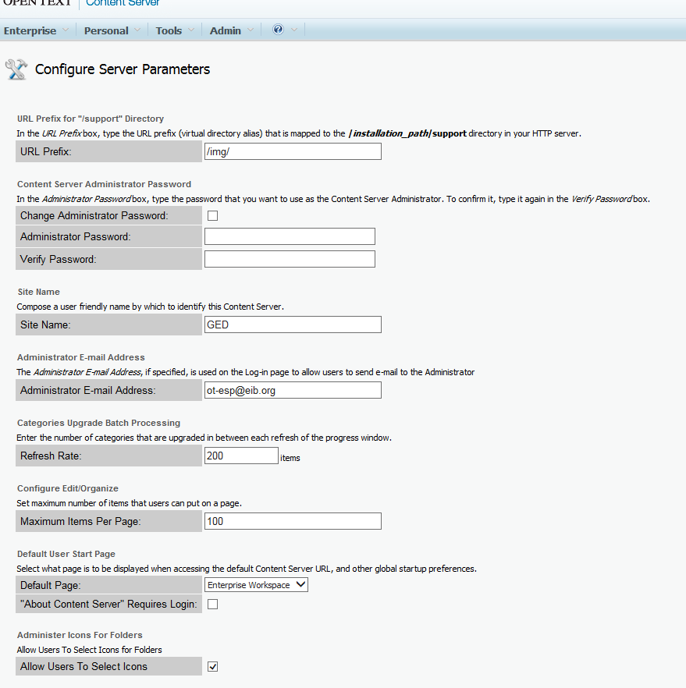

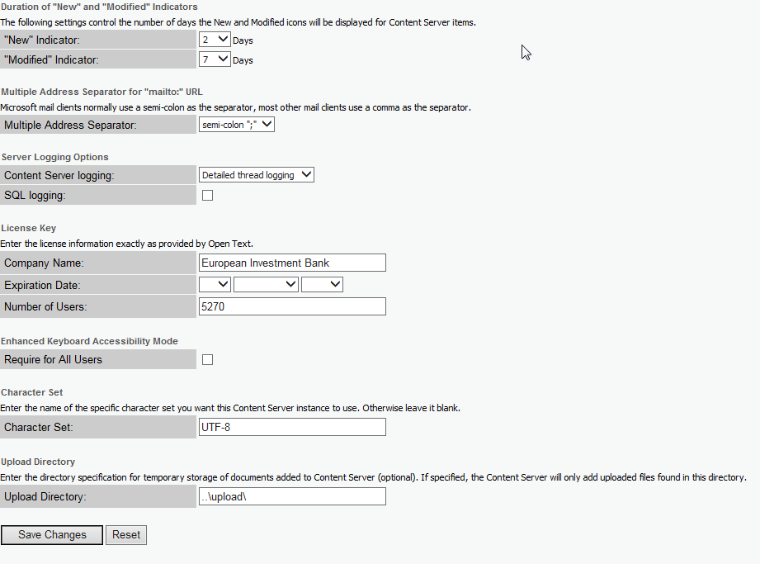

* Create a New database connection (you need to have the oracle system user connection details

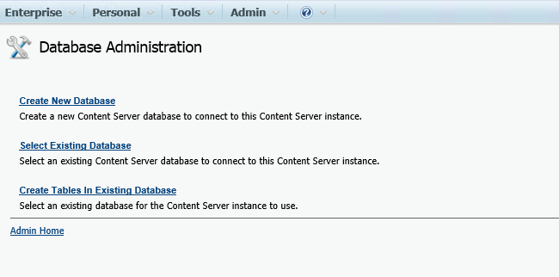

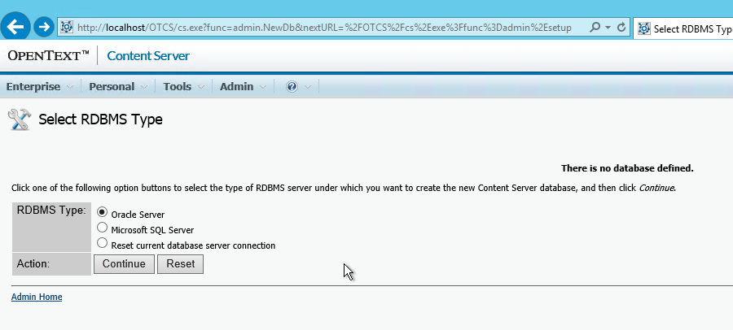

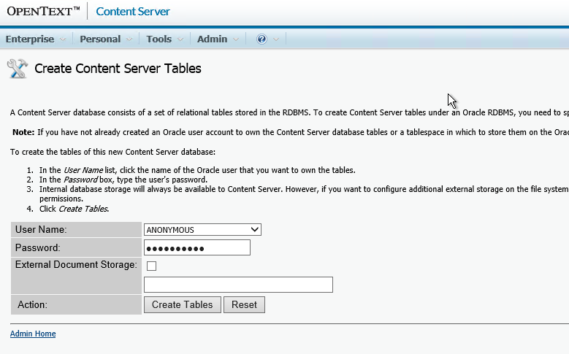

* Create a table space

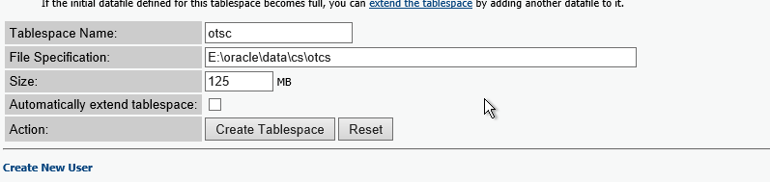

* Create a New schema user

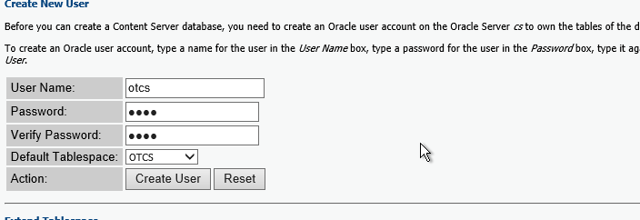

* Set up WebDav

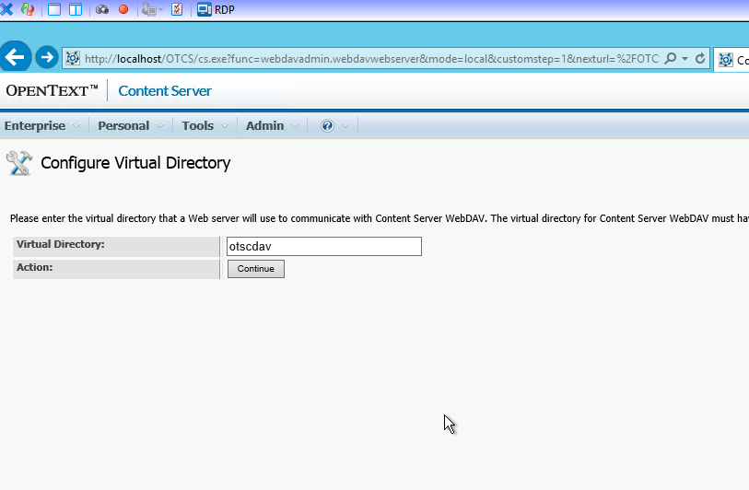

* Create a New Enterprise Data Source

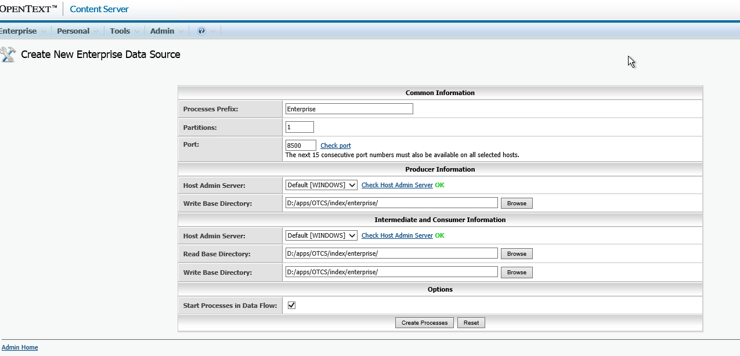

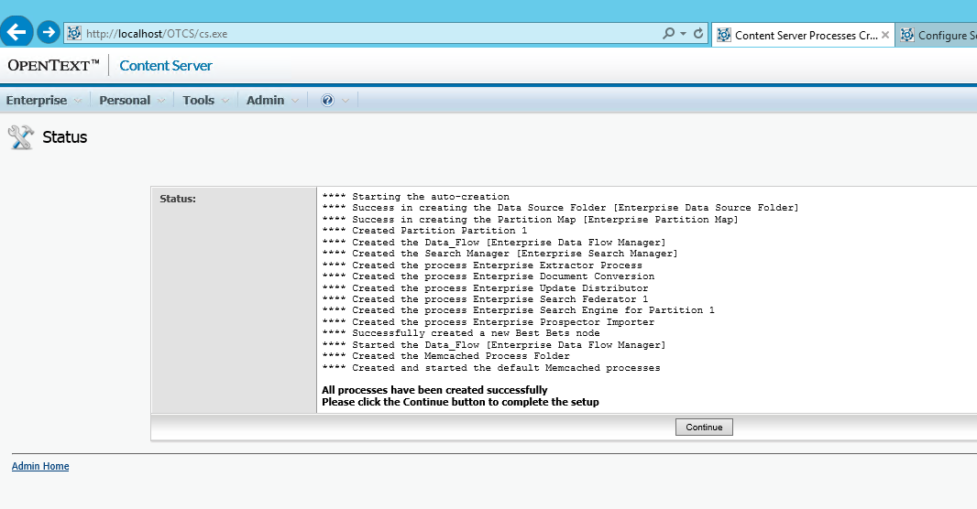

* Set up the license.

Access the following url to get create and download a license

<https://support.opentext.com/portal/site/css?_ga=1.3993523.2082142244.1461655686>

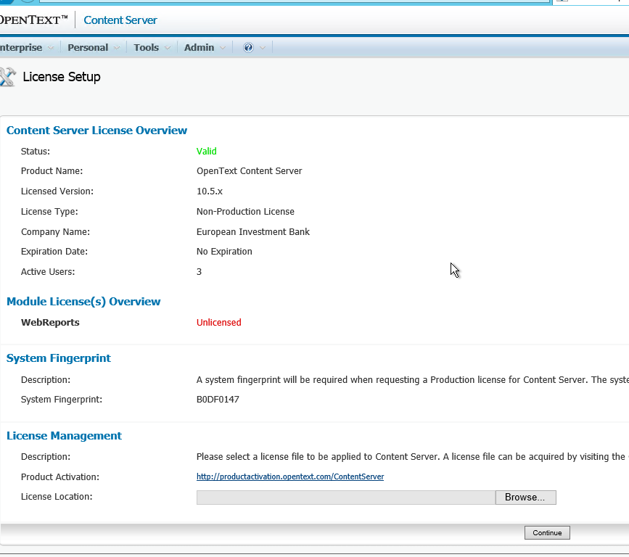

Et Voila

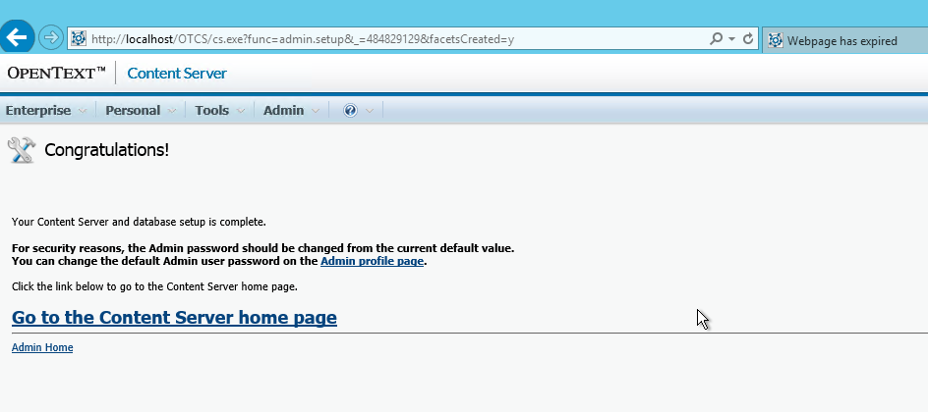

* Add the port, 80, 2099, 5858, 8080, 3099, 8000-9000 to the OTCS_Inbound and OTCS_Outbound firewall rules

## Install Optional Module

* Install the optional module located in the following location

\\vmp-fs-09.beilux.eib.org\v_disk_01$\programs\EA_admin\OpenText\Admin\Upgrade\Software\OT\10.5\Module

## HotFixes and Latest Patches

* Stop the CS services
* Back up the OTCS_HOME
* Apply the hotfix Assemble located below

\\vmp-fs-09.beilux.eib.org\v_disk_01$\programs\EA_admin\OpenText\Admin\Upgrade\Software\OT\10.5\Hotfixes\Staging

* Start the CS services
* R-Extract the Admin Help data source

## Align the opentext.ini to EIB standard

* Update the opentext.ini located in the otcs_home\config based on the entries from the current back end production environment.

# VM Ethernet Configuration.

## Disable Recv Segment Coalescing (IPv4)

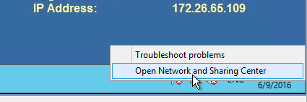

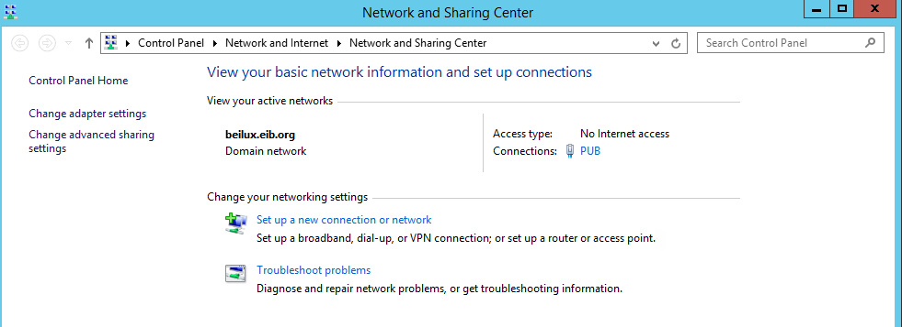

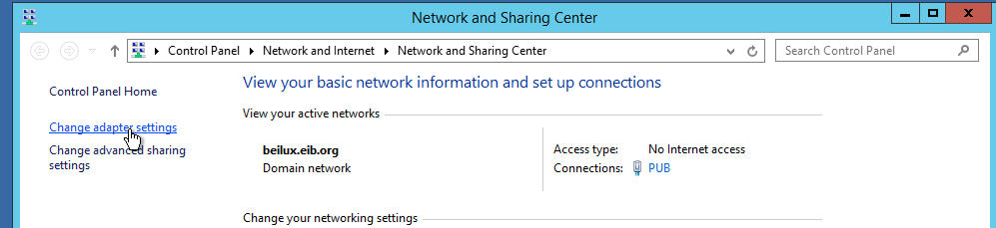

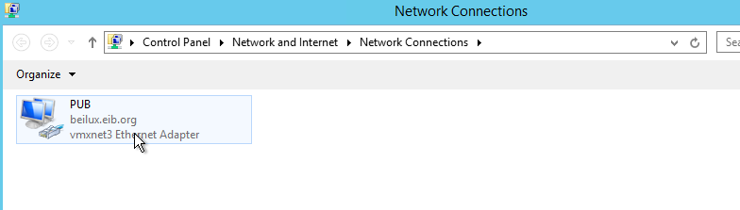

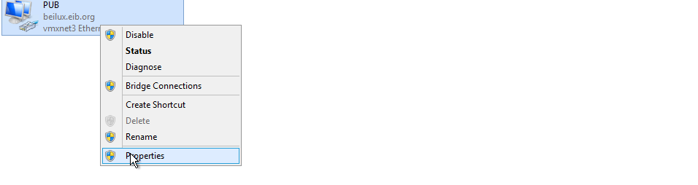

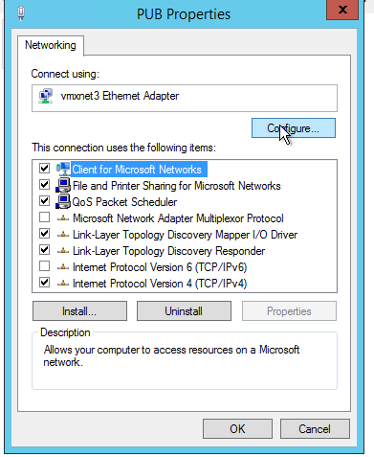

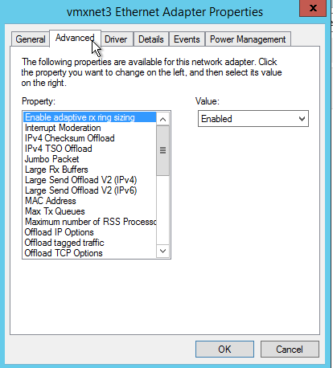

Set Recv Segment Coalescing (IPV4) to disable.

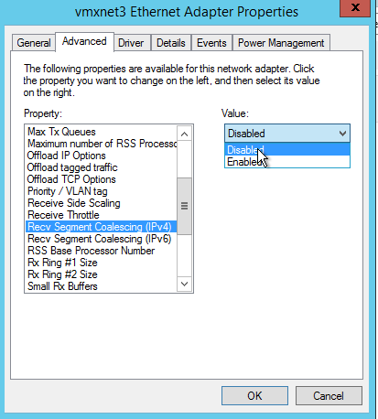

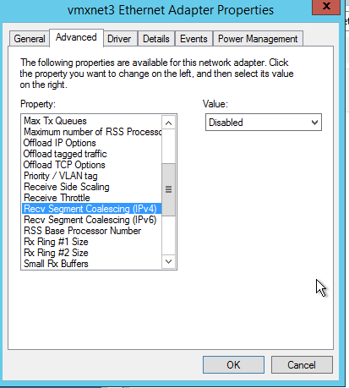

# Apache 2.4.x

## Installation

* Create the following folder structure

D:\apps\Apache\

* Copy the Apache tomcat installer “apache-tomcat-8.0.33.exe” from the source location

\\vmp-fs-09.beilux.eib.org\v_disk_01$\programs\EA_admin\OpenText\Admin\Upgrade\Software\Apache

To the newly created structure: D:\apps\Tomcat\

* Run the vc_redist_x64/86.exe installer
* Extract the httpd-2.4.23-win64-VC14.zip in “D:\apps\Apache\”
* Edit the Apache configuration file “httpd.conf” as below

1. ServerRoot "D:/apps/Apache"
2. Listen 28088
3. DocumentRoot "D:/apps/Apache/htdocs"
4. <Directory "D:/apps/Apache/htdocs">

* Access the D:\apps\Apache\bin and pin the **ApacheMonitor.exe** on the pin Taskbar

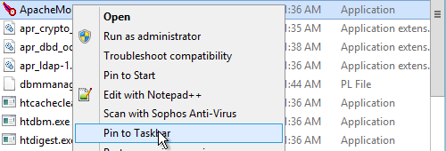

* Restart the server
* RDP to the server and run cmd as administrator

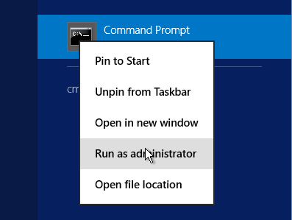

* Cd to D:\apps\Apache\bin
* Run “httpd.exe -k install”
* Run “httpd.exe -k runservice”
* Test access internally and externally to the server IE and past <http://localhost:28088/index.html> / http://<hostname>:28088/index.html

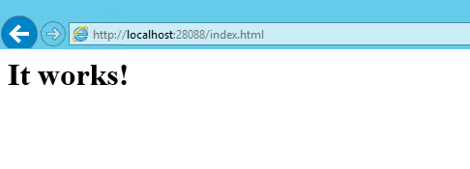

* Cd to D:\apps\Apache\bin
* Run “httpd.exe -k install”
* Run “httpd.exe -k runservice”
* Test access internally and externally to the server IE and past <http://localhost:28088/index.html> / http://<hostname>:28088/index.html

## Ged Set up

* Cd to D:\apps\Apache\conf
* Update the httpd.conf as below <https://ged.beilux.eib.org/ged/ged.dll/open/74960115>
* Save the httpd.conf
* Restart the apache services

# NSSM - the Non-Sucking Service Manager Installation.

* You can find more information about NSSM on the following link <https://nssm.cc/usage>

* Create the following folder structure

D:\apps\ nssm-2.24

* Copy the content of the folder name “nssm-2.24” from the source location

\\vmp-fs-09.beilux.eib.org\v_disk_01$\programs\EA_admin\OpenText\Admin\Upgrade\Software\nssm-2.24

To the newly created structure: D:\apps\ nssm-2.24

* Update the window path as below

From: **C:\ProgramData\Oracle\Java\javapath;D:\apps\Oracle\product\12.1.0\client\bin;%SystemRoot%\system32;%SystemRoot%;%SystemRoot%\System32\Wbem;%SYSTEMROOT%\System32\WindowsPowerShell\v1.0\**

To : **C:\ProgramData\Oracle\Java\javapath;D:\apps\Oracle\product\12.1.0\client\bin;%SystemRoot%\system32;%SystemRoot%;%SystemRoot%\System32\Wbem;%SYSTEMROOT%\System32\WindowsPowerShell\v1.0\;D:\apps\Java\8u102-i586;D:\apps\nssm-2.24\win64;D:\apps\nssm-2.24\win32**

# Content Server Agent Set up with NSSM

<https://nssm.cc/usage>

* Create the following folder structure

D:\apps\serverAgent

* Copy the content of the folder name “nssm-2.24” from the source location

\\vmp-fs-09.beilux.eib.org\v_disk_01$\programs\EA_admin\OpenText\Admin\Upgrade\Software\serverAgent

To the newly created structure: D:\apps\serverAgent

* Edit the file D:\apps\serverAgent\startAgent.bat as below

java -jar D:\apps\serverAgent\ServerAgent1.jar <server ip address> 2099 <server ip address> 8884

eg: java -jar D:\apps\serverAgent\ServerAgent1.jar 172.26.65.119 2099 172.26.65.119 8884

* Launch the CMD as an Administrator
* CD to D:\apps\ nssm-2.24,
* Run the command below

**nssm install "Content Server ServerAgent" D:\apps\serverAgent\startAgent.bat**

**nssm set "Content Server ServerAgent" AppDirectory D:\apps\serverAgent**

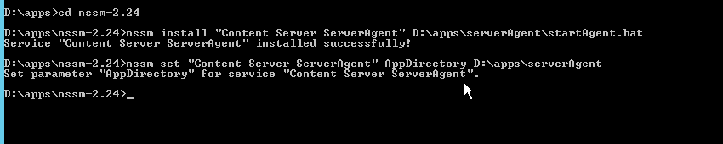

* The result should be a newly created services as below

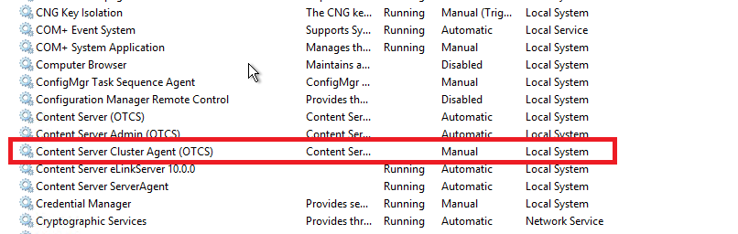

* Useful Command

nssm remove <servicename>

eg: **nssm remove "Content Server ServerAgent"**

# Open Text Monitoring Agent Set up with NSSM

<https://nssm.cc/usage>

* Create the following folder structure

E:\apps\OTMonitoringAgent

* Copy the content of the folder name “nssm-2.24” from the source location

\\vmp-fs-09.beilux.eib.org\v_disk_01$\programs\EA_admin\OpenText\Admin\Upgrade\Software\OTMonitoringAgent

To the newly created structure: E:\apps\OTMonitoringAgent

* Launch the CMD as an Administrator
* CD to D:\apps\ nssm-2.24,
* Run the command below

**nssm install "Open Text Monitoring Agent" E:\apps\OTMonitoringAgent\run.bat**

**nssm set "Open Text Monitoring Agent" AppDirectory E:\apps\OTMonitoringAgent**

* The result should be a newly created services as below

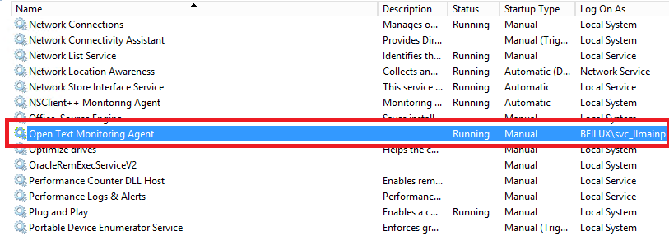

* Useful Command

nssm remove <servicename>

nssm edit <servicename>

eg: **nssm remove "Open Text Monitoring Agent"**

**nssm edit "Open Text Monitoring Agent"**